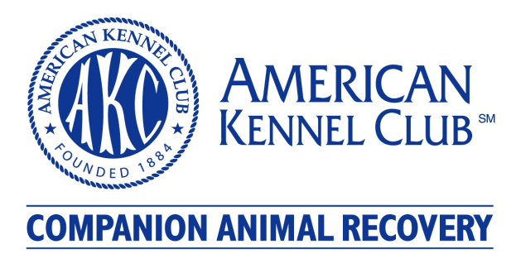
Puppy Microchip Information
Pet Call Name (If known, can be updated later): | ______________________________________________________
Primary Contact
First Name: | ______________________________________________________
Last Name: | ______________________________________________________
Address: | ______________________________________________________
City: | ______________________________________________________
State: | Washington
Zip: | ______________________________________________________
Home Phone #: | ______________________________________________________
Work Phone #: | ______________________________________________________
*Mobile Phone #: | ______________________________________________________
*Text Message Email: | ______________________________________________________
*Email: | ______________________________________________________
*By entering this field I agree to receive notification through this connection regarding my found pet.
Select Your Collar Tag
Blue Collar Tag  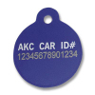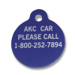 | - Blue anodized aluminum.  - Extra thick (65 thousandths of an inch) - thicker than industry standard.  - 1" diameter with loop for supplied heavy-duty O ring collar attachment.  - Backed by a full 18 month guarantee.
Black Collar Tag  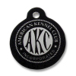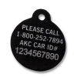 | - Black anodized aluminum.  - Extra thick (65 thousandths of an inch) - thicker than industry standard.  - 1" diameter with loop for supplied heavy-duty O ring collar attachment.  - Manufactured using a highly specialized anodizing process.  - Backed by a full 2 year guarantee.
Stainless Steel Collar Tag  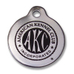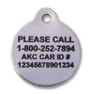 | - Highly polished stainless steel.  - 50 thousandth of an inch thick.  - Will not rust, corrode or tarnish.  - 1 1/8" diameter with loop for supplied heavy-duty O ring collar attachment.  - Double sided (with the AKC Logo on front, id and 800 Number on back.)  - Backed by a full 3 year guarantee.
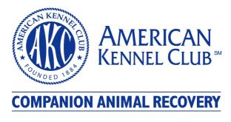
AKC Companion Animal Recovery (AKC CAR), an affiliate of the American Kennel Club®, is the nation's largest not-for-profit pet identification and 24/7 recovery service provider. With millions of pets enrolled, hundreds of thousands of pets have been recovered through our service.
Founded in 1995, AKC CAR makes donations annually for veterinary student scholarships and manages the AKC CAR Canine Support and Relief Fund, which provides grants for search and rescue teams and donations for natural disaster relief.

Your puppy’s enrollment with AKC Companion Animal Recovery provides:
- A simple, one-time enrollment process; unlike others that charge you annual subscription fees.
- AKC collar tag included with enrollment
- Unlimited free updates, including phone number and address changes.
- And because we are not for profit, we are all about giving Back, while extending the protection you provide your pet we also support animals in need.

Lost Pet Alert
(Not included with AKC CAR Registration, available for an additional $19.95)
Available with your AKC CAR enrollment, lost pet alerts are the most proactive way to recover lost and stolen pets because every second counts. This service connects you with a virtual community of owners, animal shelters, veterinarians and related businesses. The AKC CAR Lost Pet Alert includes:
- A membership that covers the life of your pet.
- Printable posters are sent to all participating members within a 50-mile radius where your pet was last seen.
- Personal account information accessible via password-protected website.
- Your own web page containing your pet's photo, description and emergency contact information in case your pet is lost or stolen.
- Free updates to your pet's information.
- Immediate notification of any sighting or related information regarding your lost pet.
- An urgent message being placed in your box and notification via a phone call to arrange a reunion when your pet is found.

Update My Pet Records
We encourage you to keep your records updated so that we can quickly return your pet home. Unique to AKC Companion Animal Recovery service, you can make unlimited free updates, including phone number and address changes. Even if you go on a short vacation with your pet, please update your online records with your temporary address and phone number.

Transfer Your Pet
Ensure peace of mind for new pet owners, and transfer pet records to pass along the benefits that microchipping and enrollment to new pet owners.

Report a Lost or Found Pet
Please use our 24-hour Recovery Hotline to Report a Lost or Found Pet. Recovery Hotline: 1-800-252-7894.
- Press 2 for changes to your pet's enrollment information. If possible, please fax, e-mail or mail changes so that we can better serve those customers calling to report lost or found animals.
- Press 3 to order a replacement collar tag.
- Press 4 to check the status of your pet's enrollment.
- Press 0 for all other inquiries.
http://akccar.org

